A

Project Report

On

**TITLE OF PROJECT**

**NOTES TAKING WEBSITE**

Submitted in partial fulfilment of the requirement for the V semester

**Bachelor of Technology (CSE)**

By

**Name of the Students’** (CHANDAN SINGH) **University Roll No** (2061792)

**Name of the Students’(**PRIYANSHU SHAHI)**University** **Roll No** (2061896)

**Name of the Students’** (GAURAV SUNAL) **University Roll No** (2061813)

…

**Under the Guidance of (Class Coordinator)**

**Name of Faculty (Mr.** **Aviral Awasthi)**

**Designation (GEHU Bhimtal Campus)**

**Department of CSE**



**DEPARTMENT OF COMPUTER SCIENCE & ENGINEERING**

**GRAPHIC ERA HILL UNIVERSITY, BHIMTAL CAMPUS**

**SATTAL ROAD, P.O. BHOWALI**

**DISTRICT- NAINITAL-263132**

**2021 – 2022**

**STUDENT’S DECLARATION**

I **GAURAV SUNAL**, here by declare the work, which is being presented in the project, entitled “**NOTES TAKING WEBSITE** “ in partial fulfilment of the requirement for the award of the degree **B.Tech. CSE** in the session **2021-2022**, is an authentic record of my own work carried out under the supervision of Graphic Era Hill University college guide name Mr. Aviral Awasthi.

The matter embodied in this project has not been submitted by me for the award of any other degree.

Date: **GAURAV SUNAL**



I **PRIYANSHU SHAHI**, here by declare the work, which is being presented in the project, entitled “**NOTES TAKING WEBSITE**“ in partial fulfilment of the requirement for the award of the degree **B.Tech. CSE** in the session **2021-2022**, is an authentic record of my own work carried out under the supervision of Graphic Era Hill University college guide name Mr. Aviral Awasthi.

The matter embodied in this project has not been submitted by me for the award of any other degree.

Date: **PRIYANSHU SHAHI**

I **CHANDAN SINGH**, here by declare the work, which is being presented in the project, entitled “**NOTES TAKING WEBSITE** “ in partial fulfilment of the requirement for the award of the degree **B.Tech. CSE** in the session **2021-2022**, is an authentic record of my own work carried out under the supervision of Graphic Era Hill University college guide name Mr. Aviral Awasthi.

The matter embodied in this project has not been submitted by me for the award of any other degree.

Date: **CHANDAN SINGH**

**CERTIFICATE**

The term work of **“NOTES TAKING WEBSITE”** being submitted by I **PRIYANSHU SHAHI** d/o /s/o **Mr. Lalit Mohan Shahi** ,roll no **2061896** to Graphic Era Hill University Bhimtal Campus for the award of bona fide work carried out by him/her. He has worked under my guidance and supervision and fulfilled the requirement for the submission of this work report.

**(……………………..) (……………………)**

**(Mr. Aviral Awasthi) (Dr. Ankur Singh Bisht)**

**Project guide** **HOD, CSE Dept.**

**CERTIFICATE**

The term work of **“NOTES TAKING WEBSITE”** being submitted by **I GAURAV SUNAL** d/o /s/o **Mr. Lalit Mohan Sunal** ,roll no **2061813** to Graphic Era Hill University Bhimtal Campus for the award of bona fide work carried out by him/her. He has worked under my guidance and supervision and fulfilled the requirement for the submission of this work report.

**(……………………..) (……………………)**

**(Mr. Aviral Awasthi) (Dr. Ankur Singh Bisht)**

**Project guide** **HOD, CSE Dept.**

**CERTIFICATE**

The term work of **“NOTES TAKING WEBSITE”** being submitted by **Chandan Singh** d/o /s/o **Uday Singh** , roll no **2061792** to Graphic Era Hill University Bhimtal Campus for the award of bona fide work carried out by him/her. He has worked under my guidance and supervision and fulfilled the requirement for the submission of this work report.

**(……………………..) (……………………)**

**(Mr. Aviral Awasthi) (Dr. Ankur Singh Bisht)**

**Project guide** **HOD, CSE Dept.**

**ACKNOWLEDGEMENT**

We take immense pleasure in thanking Honourable **“Mr. Aviral Awasthi "**, to permit me and carry out this project work with his excellent and optimistic supervision. This has all been possible due to his novel inspiration, able guidance and useful suggestions that helped me to develop as a creative researcher and complete the research work, in time.

Words are inadequate in offering my thanks to GOD for providing me everything that I need. I again want to extend thanks to our President **“Prof. (Dr.) Kamal Ghanshala”** for providing us all infrastructure and facilities to work in need without which this work could not be possible.

Many thanks to **“Dr. Ankur Singh Bisht”** **(**Designation, CSE, GEHU) and other faculties for their insightful comments, constructive suggestions, valuable advice, and time in reviewing this thesis.

**( GAURAV SUNAL )**

**gauravsunal2003@gmail.com**

**( PRIYANSHU SHAHI )**

**pwn1056@gmail.com**

**( CHANDAN SINGH )**

**Chandan.koranga07@gmail.com**

**TABLE OF CONTENTS**

**CHAPTER 1** INTRODUCTION…………………………………………………..

1.1 About…………………………………………………………………………………………………

1.2 Prologue…………………………………………………………………………………………………

1.3 Background and motivation……………………………………………………………………

1.3 Problem Statement…………………………………………………………………………………

1.4 Objectives..............................................…………………………………………………..

**CHAPTER 2** PROPOSED SYSTEM…………………………………………….

2.1 History………………………………….…………………………………………………………..

2.2 Government use………………………………………………………………………………

2.3 Commercial use………………………………………………………………………………

**CHAPTER 3** S/W REQUIREMENTS………………………………………..

3.1 Software requirements……………………………………………………………………….

**CHAPTER 4** CODING OF FUNCTION………………………………………..

4.1 Steps…………………………………………………………………………………………

**CHAPTER 5** LIMITATIONS……………………………………………………..

**CHAPTER 6** ENHANCEMENTS……………………………………………….

**CHAPTER 7** CONCLUSIONS…………………………………………………..

REFERENCES………………………………………………………

**CHAPTER 1**

**INTRODUCTION**

1.1 **ABOUT**

**NOTES TAKING WEBSITE**

Note-taking applications (also called note-taking apps) allow students to:

Store all notes and important information digitally, usually in a cloud-based storage system.

Type, write, and draw notes on the device of choice just as one would using pen and paper.

Add files, multimedia, and live recordings to their notes to enrich the meaning and context.

Collaborate and share notes with others instantaneously and in real-time.

**What is JavaScript?**

JavaScript is a high-level, often just-in-time compiled language that conforms to the ECMAScript standard.[10] It has dynamic typing, prototype-based object-orientation, and first-class functions. It is multi-paradigm, supporting event-driven, functional, and imperative programming styles. It has application programming interfaces (APIs) for working with text, dates, regular expressions, standard data structures, and the Document Object Model (DOM).

**GitHub**

GitHub is a web-based version-control and collaboration platform for software

developers. Microsoft, the biggest single contributor to GitHub, initiated an acquisition of GitHub for $7.5 billion in June, 2018. GitHub, which is delivered through a software-as-a-service (SaaS) business model, was started in 2008 and was founded on Git, an open source code management system created by Linus Torvalds to make software builds faster.

1.2 **PROLOGUE**

Note taking forces you to pay attention and helps you focus in class (or while reading a textbook). It helps you learn. Studies on learning have shown that actively engaging with the topic by listening and then summarizing what you hear helps you understand and remember the information later.

1.3 **BACKGROUND AND MOTIVATION**

Take visually clear, concise, organized, and structured notes so that they are easy to read and make sense to you later. See different formats of notes below for ideas. If you want your notes to be concise and brief, use abbreviations and symbols. Write in bullets and phrases instead of complete sentences.

1.3 **OBJECTIVES**

The objectives of NOTES TAKING WEBSITE for Real-Time Applications are given below:

* stay active and engaged during your lectures, reading and revision
* Note taking helps you pay attention.
* Developing note taking skills should help you organize information into an understandable format
* enable users to type, write, and draw on their devices just as they would on paper
* Engages your mind,keeps you alert.

**CHAPTER 2**

**PROPOSED SYSTEM**

2.1 **HISTORY**

Note-taking is the process of capturing information from a source or event. This usually takes the form of recording, writing, jotting, paraphrasing, sketching, labelling, outlining, and annotating. Note-taking applications enable users to type, write, and draw on their devices just as they would on paper. Many applications have their own unique features, storage, organization, and sharing capabilities, and it’s up to the user to identify which note-taking application will work best for their needs.

**2.2** **GOVERNMENT USE**

* It also used in many Government Services, because now days almost everything is digital . And many more use cases will be there.

**CHAPTER 3**

**S/W REQUIREMENTS**

3.1 **SOFTWARE REQUIREMENT**

|  |  |
| --- | --- |
| **Name of component** | **Specification** |
| Software used | Html,bootstrap,js |
| Packages used | Html  Css  Bootstrap  Js |
| Module | NOTES TAKING WEBSITE |
| Tools used | Html  Css  bootstrap  Js |

**CHAPTER 4**

**Coding of Function**

**Features of the NOTES TAKING WEBSITE**

**In this project, you are going to develop a Notes Taking Website that will have the following features:**

* quick and easy to use as intended
* We have made Add a Note feature for adding Notes. It will keep the note until you delete it from your own or Local Storage of a Brower get Full.
* Here we Implement Search Feature Which works Pretty fine.
* It has a nice UI which also enhances the user experience.

**UI - INTERFACE**

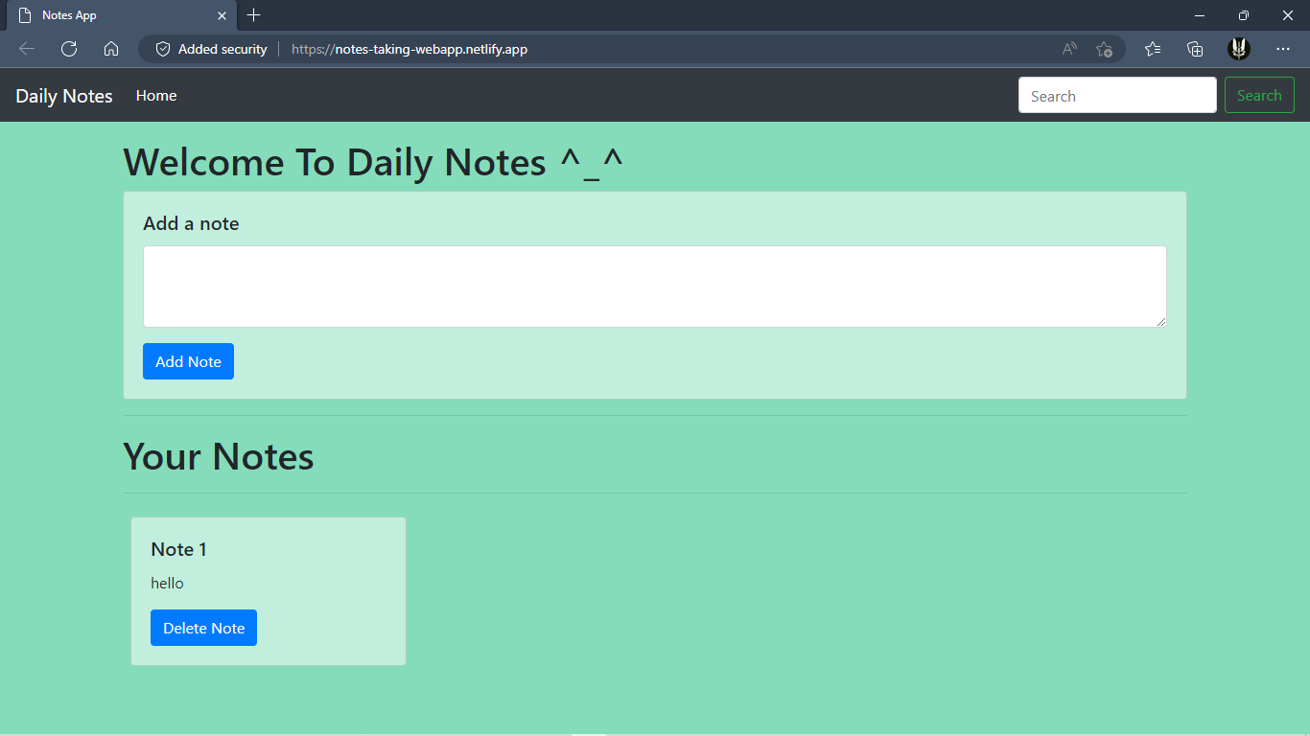

**ER DIAGRAM**

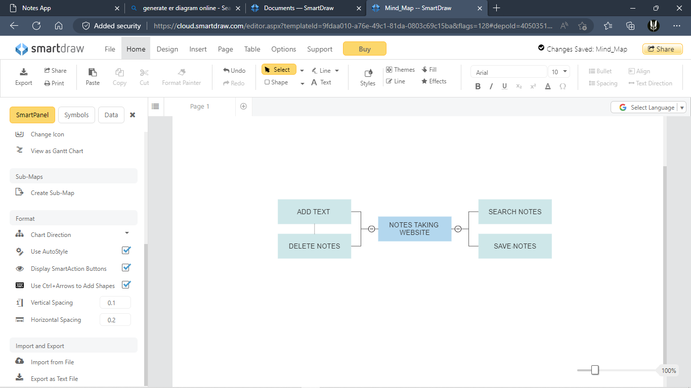

**HTML Code**

<!DOCTYPE html>

<html lang="en">

<head>

<meta charset="UTF-8" />

<meta name="viewport" content="width=device-width, initial-scale=1.0" />

<meta http-equiv="X-UA-Compatible" content="ie=edge" />

<title>Notes App</title>

<link rel="stylesheet" href="https://stackpath.bootstrapcdn.com/bootstrap/4.3.1/css/bootstrap.min.css"

integrity="sha384-ggOyR0iXCbMQv3Xipma34MD+dH/1fQ784/j6cY/iJTQUOhcWr7x9JvoRxT2MZw1T" crossorigin="anonymous" />

<!-- <link rel="stylesheet" href="style.css" /> -->

<style>

body {

background-color: #85dcba;

}

.card {

background-color: #c2eedd;

}

</style>

</head>

<body>

<nav class="navbar navbar-expand-lg navbar-dark bg-dark">

<a class="navbar-brand" href="#">Daily Notes</a>

<button class="navbar-toggler" type="button" data-toggle="collapse" data-target="#navbarSupportedContent"

aria-controls="navbarSupportedContent" aria-expanded="false" aria-label="Toggle navigation">

<span class="navbar-toggler-icon"></span>

</button>

<div class="collapse navbar-collapse" id="navbarSupportedContent">

<ul class="navbar-nav mr-auto">

<li class="nav-item active">

<a class="nav-link" href="#">Home <span class="sr-only">(current)</span></a>

</li>

</ul>

<form class="form-inline my-2 my-lg-0">

<input class="form-control mr-sm-2" id="searchTxt" type="search" placeholder="Search"

aria-label="Search" />

<button class="btn btn-outline-success my-2 my-sm-0" type="submit">

Search

</button>

</form>

</div>

</nav>

<div class="container my-3">

<h1>Welcome To Daily Notes ^_^</h1>

<div class="card">

<div class="card-body">

<h5 class="card-title">Add a note</h5>

<div class="form-group">

<textarea class="form-control" id="addTxt" rows="3"></textarea>

</div>

<button class="btn btn-primary" id="addBtn">Add Note</button>

</div>

</div>

<hr />

<h1>Your Notes</h1>

<hr />

<div id="notes" class="row container-fluid"></div>

</div>

<script src="https://code.jquery.com/jquery-3.3.1.slim.min.js"

integrity="sha384-q8i/X+965DzO0rT7abK41JStQIAqVgRVzpbzo5smXKp4YfRvH+8abtTE1Pi6jizo"

crossorigin="anonymous"></script>

<script src="https://cdnjs.cloudflare.com/ajax/libs/popper.js/1.14.7/umd/popper.min.js"

integrity="sha384-UO2eT0CpHqdSJQ6hJty5KVphtPhzWj9WO1clHTMGa3JDZwrnQq4sF86dIHNDz0W1"

crossorigin="anonymous"></script>

<script src="https://stackpath.bootstrapcdn.com/bootstrap/4.3.1/js/bootstrap.min.js"

integrity="sha384-JjSmVgyd0p3pXB1rRibZUAYoIIy6OrQ6VrjIEaFf/nJGzIxFDsf4x0xIM+B07jRM"

crossorigin="anonymous"></script>

<!-- <script src="js/app.js"></script> -->

<script src="index.js"></script>

</body>

</html>

**JavaScript Code**

console.log("Welcome to notes app. This is app.js");

showNotes();

// If user adds a note, add it to the localStorage

let addBtn = document.getElementById("addBtn");

addBtn.addEventListener("click", function(e) {

let addTxt = document.getElementById("addTxt");

let notes = localStorage.getItem("notes");

if (notes == null) {

notesObj = [];

} else {

notesObj = JSON.parse(notes);

}

notesObj.push(addTxt.value);

localStorage.setItem("notes", JSON.stringify(notesObj));

addTxt.value = "";

// console.log(notesObj);

showNotes();

});

// Function to show elements from localStorage

function showNotes() {

let notes = localStorage.getItem("notes");

if (notes == null) {

notesObj = [];

} else {

notesObj = JSON.parse(notes);

}

let html = "";

notesObj.forEach(function(element, index) {

html += `

<div class="noteCard my-2 mx-2 card" style="width: 18rem;">

<div class="card-body">

<h5 class="card-title">Note ${index + 1}</h5>

<p class="card-text"> ${element}</p>

<button id="${index}"onclick="deleteNote(this.id)" class="btn btn-primary">Delete Note</button>

</div>

</div>`;

});

let notesElm = document.getElementById("notes");

if (notesObj.length != 0) {

notesElm.innerHTML = html;

} else {

notesElm.innerHTML = `Nothing to show! Use "Add a Note" section above to add notes.`;

}

}

// Function to delete a note

function deleteNote(index) {

// console.log("I am deleting", index);

let notes = localStorage.getItem("notes");

if (notes == null) {

notesObj = [];

} else {

notesObj = JSON.parse(notes);

}

notesObj.splice(index, 1);

localStorage.setItem("notes", JSON.stringify(notesObj));

showNotes();

}

let search = document.getElementById('searchTxt');

search.addEventListener("input", function(){

let inputVal = search.value.toLowerCase();

// console.log('Input event fired!', inputVal);

let noteCards = document.getElementsByClassName('noteCard');

Array.from(noteCards).forEach(function(element){

let cardTxt = element.getElementsByTagName("p")[0].innerText;

if(cardTxt.includes(inputVal)){

element.style.display = "block";

}

else{

element.style.display = "none";

}

// console.log(cardTxt);

})

})

**CHAPTER 5**

**LIMITATIONS**

* Can’t Mark a note as important.
* Can’t highlight as important .
* Separate notes by user.
* Sync and host to web server.

**CHAPTER 6**

**ENHANCEMENTS**

* Add Title
* Mark a note as Important
* Separate notes by user
* Sync and host to web server

**CHAPTER 7**

**CONCLUSIONS**

we need to outline why notetaking is such an effective learning tool. Simply put, there are four primary reasons for taking notes during your classes:

* to concentrate better
* to remember better
* to understand better
* to revise better

**REFERENCES**

* Google.com
* fedtechmagazine.com
* [www.researchgate.net](http://www.researchgate.net/)